Date:15/10/2026
ASSESSMENT TOOL 3 – CODING CHALLENGE
DSA0308-NLP
Reg no:192472263 Name.V. Gagan Kumar Reddy

1. Problem Statement:
A software company is developing a user registration system. Before creating an account, the system must
validate user credentials based on predefined security policies.
Program:
import re

email = input("Enter Email Address: ")
password = input("Enter Password: ")
mobile = input("Enter Mobile Number: ")

email_pattern = r'^[A-Za-z][A-Za-z0-9._]*@[A-Za-z]+\.(com|org|edu|net|in)$'
password_pattern = r'^(?=.*[A-Z])(?=.*[a-z])(?=.*\d)(?=.*[@#$%&!]).{8,}$'
mobile_pattern = r'^[6-9]\d{9}$'

if re.match(email_pattern, email):
print("Valid Email")
else:
print("Invalid Email")

if re.match(password_pattern, password):
print("Strong Password")
else:
print("Weak Password")

if re.match(mobile_pattern, mobile):
print("Valid Mobile Number")
else:
print("Invalid Mobile Number")
Output:

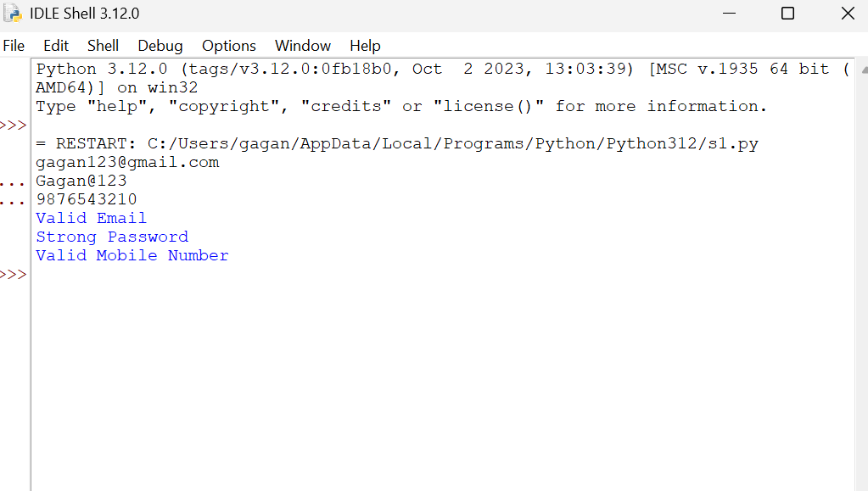

2. Problem Statement
Develop a Python-based Deterministic Finite Automata (DFA) simulator.
Program:
states = ["q0", "q1", "q2"]
alphabet = ["a", "b"]

transition = {
("q0", "a"): "q1",
("q0", "b"): "q0",
("q1", "a"): "q1",
("q1", "b"): "q2",
("q2", "a"): "q1",
("q2", "b"): "q0"
}

initial = "q0"
final = ["q2"]

n = int(input())

for i in range(n):
string = input().strip()
current = initial
path = [current]
valid = True

for symbol in string:
if symbol not in alphabet:
valid = False
break

current = transition[(current, symbol)]
path.append(current)

print("Transition Path:")
print(" -> ".join(path))

if valid and current in final:
print("Accepted")
else:
print("Rejected")
Output: 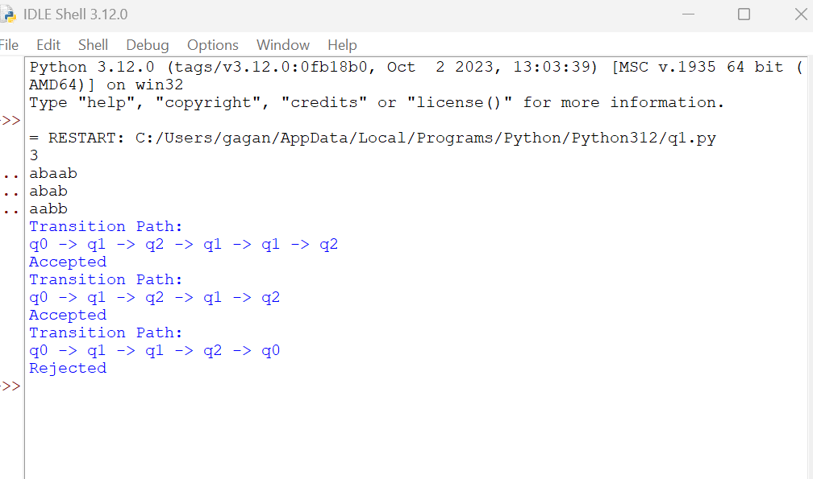

3. Problem Statement
Develop a Python-based text search engine that performs pattern matching using Regular Expressions.
Program:
import re

text = input()
print("1. Search Date")
print("2. Search Phone Number")
print("3. Search Hashtag")
print("4. Search Mention")
print("5. Search Prefix")
print("6. Search Suffix")
print("7. Search Word")

choice = input()

if choice == "1":
pattern = r'\b\d{2}/\d{2}/\d{4}\b'
elif choice == "2":
pattern = r'\b[6-9]\d{9}\b'
elif choice == "3":
pattern = r'#[A-Za-z0-9_]+'
elif choice == "4":
pattern = r'@[A-Za-z0-9_]+'
elif choice == "5":
prefix = input()
pattern = r'\b' + re.escape(prefix) + r'\w*'
elif choice == "6":
suffix = input()
pattern = r'\b\w*' + re.escape(suffix) + r'\b'
elif choice == "7":
word = input()
pattern = r'\b' + re.escape(word) + r'\b'
else:
print("Invalid Choice")
pattern = None

if pattern is not None:
result = re.findall(pattern, text, re.IGNORECASE)
if result:
for item in result:
print(item)
else:
print("No matches found")
Output:
